**Audio Experience || Zhou Yankai**

**Melody Motion**



**Abstract**

The "Melody Motion" project enables the generation of different musical notes through capturing users' hand movements and spatial displacements via a computer's video camera. Participants can creatively wave their hands in the air, allowing the notes to connect coherently and produce beautiful melodies. This process allows users to freely express their emotions, which are then transformed into music that uniquely represents their mood.

This project aims to bridge the gap between musical creation and music beginners, offering an engaging and visual way for every user to effortlessly generate melodies. The implementation relies on the computer's video camera, Google's open-source hand tracking model Mediapipe, web-based code, and the acoustic programming software Max/MSP.

The design was completed under the guidance of instructor Lorenzo Picinali during the Audio course at the Dyson School of Design Engineering, Imperial College London, by two students, Yang Liang and Yankai Zhou.

**Final Installation Overview**

**xyz coordinate mapping tone key method**

**Virtual piano key**

**Hand tracking area**

**Hand tracking area**

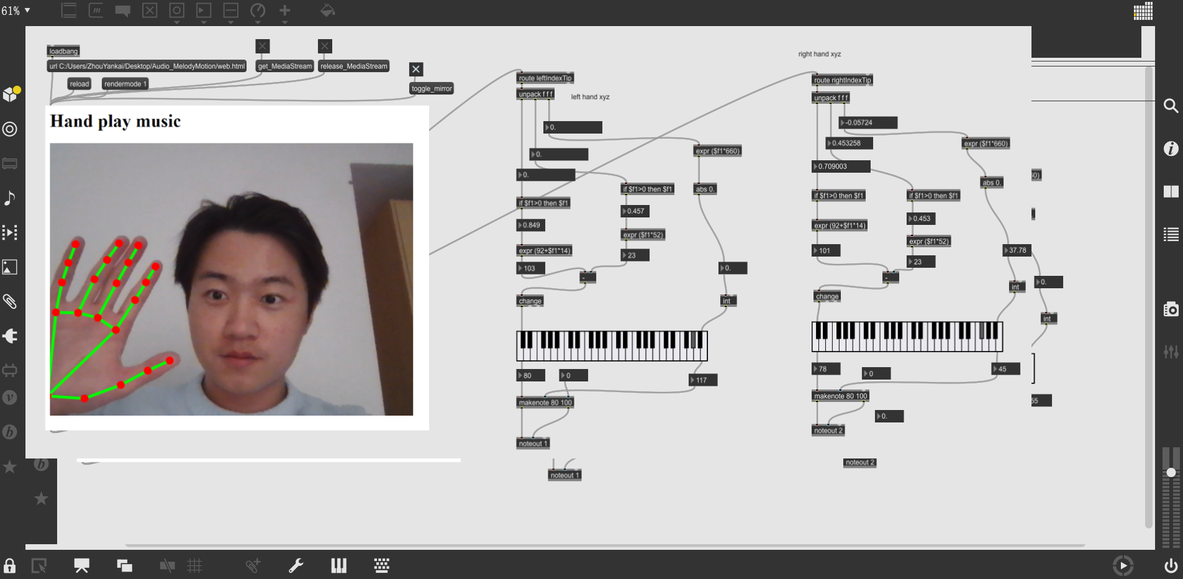

**Work Package & Plan**

The ultimate objective of the project is to facilitate natural and intuitive interaction with music through hand movements, making the experience accessible and engaging for both musicians and non-musicians. The project plan is outlined as follows:

1. Establish the final goal of the project to simulate triggering a piano to produce melodies, and further define how hand movements (such as position, speed, and direction) will map to different musical notes.
2. Select an appropriate method for tracking hand positions in space. Further process the spatial coordinates of the finger joints to map various hand positions and movements to the sounds of musical instruments.
3. Implement sound mapping using Max/MSP and further process and optimize the sound of the instruments, ensuring users can intuitively understand and operate the Max software.
4. Conduct preliminary tests to ensure the system functions as expected. Based on the test results, adjust sensor sensitivity, audio mapping, and the user interface for improved performance.

In the workflow outlined above, the first three components are conducted concurrently. I am personally responsible for components 1 and 2, and the following discussion will primarily focus on my contributions. Given that this design is almost entirely software-based, it involves complex and extensive coding, all of which can be found [here](https://github.com/Zhou-Yankai/Audio_MelodyMotion).

**Software System of Installation**

Figure 1 displays the overall implementation logic of the project, highlighting its two crucial components: 1. Successfully integrating the hand tracking model into Max/MSP to ensure immediate and accurate tracking. 2. Mapping the spatial position of the hand to different piano keys and defining the changes in sound frequency and volume based on the participants' hand-waving habits. I was solely responsible for the first part, while the second part was explored and completed in collaboration with my team member, Yang Liang.

However, after conducting preliminary installation tests, we found that this straightforward mapping of coordinates to piano keys led to numerous issues with sound production. This realization led to the emergence of a third critical component: the processing and optimization of sound. This includes dealing with noises created during rapid hand movements across the camera, the tremolo effect caused by overly sensitive hand tracking models resulting in high-frequency coordinate vibrations when the hand remains static, and the undesirable sound mapping equations that resulted in a minor key output, giving the music a consistently dark tone.

The third part, focusing on sound optimization, was independently completed by Yang Liang.

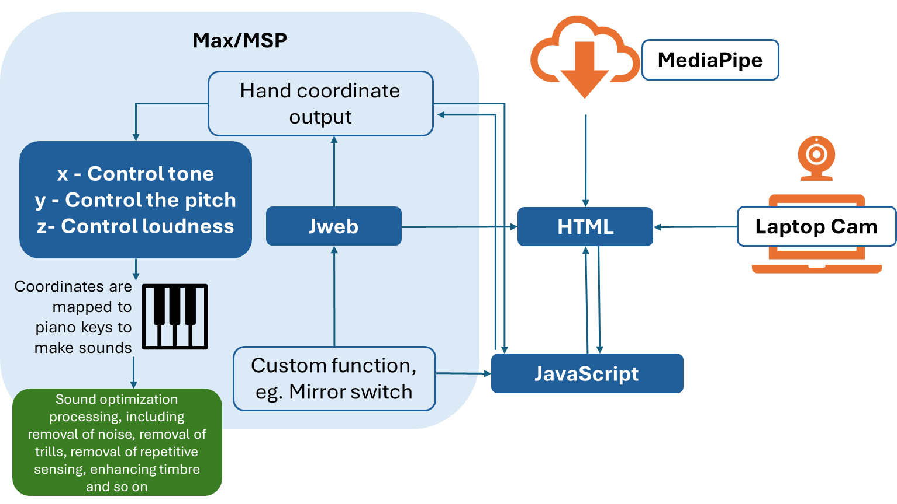

*Figure 1: Software Logic*

**Hands Landmarks & Tracking**

Hand tracking and recognition is a complex task and engineering challenge, and it serves as the core of our project. The accuracy of tracking and recognition directly impacts the expressiveness of our installation. To ensure that anyone interested in this design could experience it anytime and anywhere, I decided against using external hand tracking cameras, such as Leap Motion, and instead opted for the computer's built-in camera combined with software. Initially, I attempted to use the OpenCV library in Python for hand edge detection, but the accuracy and background removal were not satisfactory, resulting in considerable noise. Consequently, I turned to Google's open-source hand tracking model, Mediapipe, which enabled real-time hand tracking feedback.

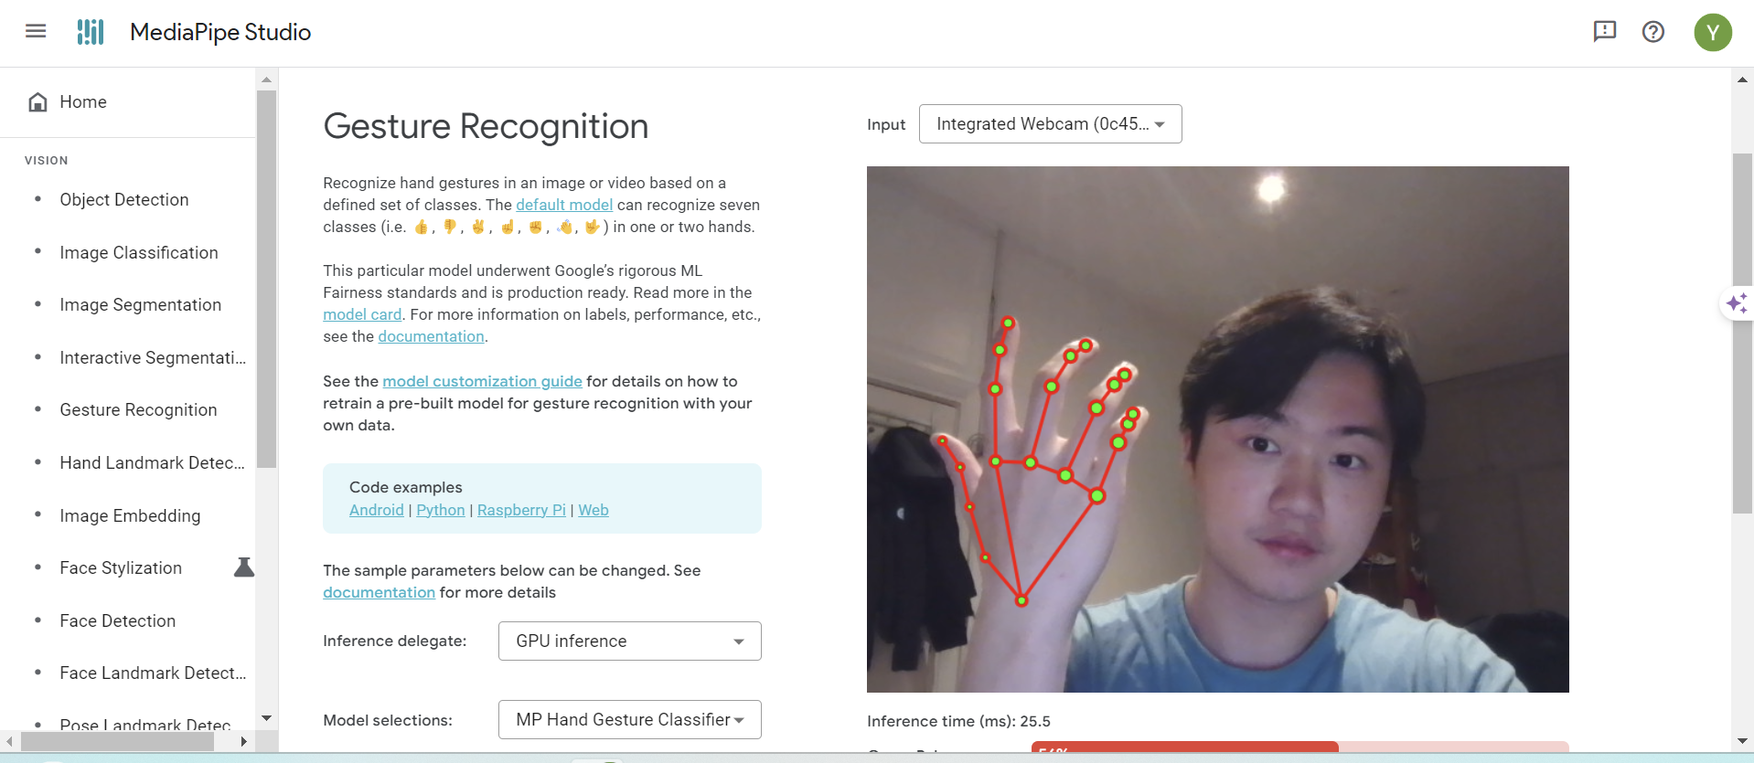

*Figure 2: MediaPipe Demo*

The final presentation form of our product is embedded within the Max/MSP interface. Hence, I chose to use Max's jweb object to embed an HTML webpage and simulate frontend interactive functionalities using JavaScript code. An HTML webpage was created featuring real-time video capture from the computer's camera, into which the Mediapipe model is integrated for the recognition and tracking of hands appearing in the video.

**Switch for video**

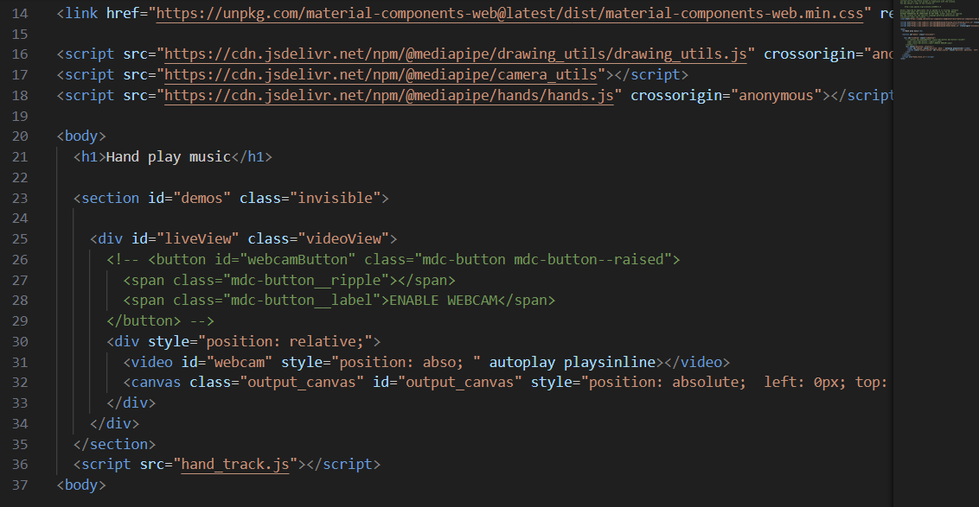 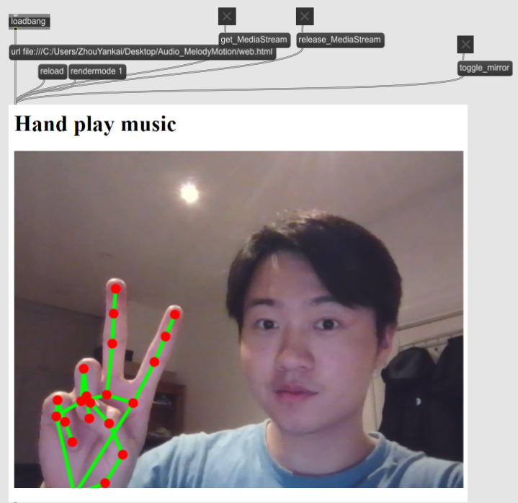

**Video image switching**

**Page reload function**

**URL of the HTML web page**

*Figure 3: HTML & Max*

Since Max itself lacks the functionality to set toggle switches for controlling the jweb object's access to video and camera permissions, I wrote two JavaScript functions to enable and disable video capture and hand tracking. Similar to the function controlling video mirroring, these three functionalities implemented via JavaScript require encapsulation through the ‘window.max.bindInlet()’ method to enable interactive use within the Max application interface. The ‘bindInlet()’ method is a means to monitor any commands entered from the Max environment to the jweb object and return predefined values. Figure 4 showcases the relevant JavaScript code content.

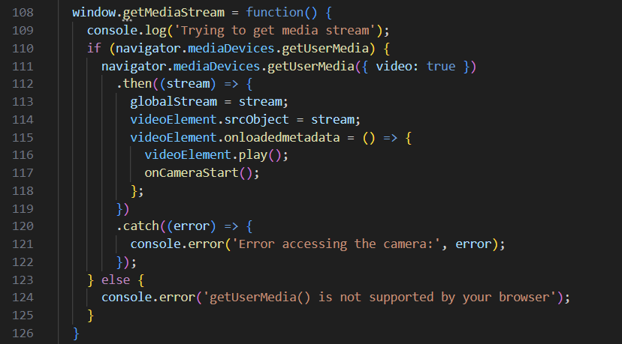 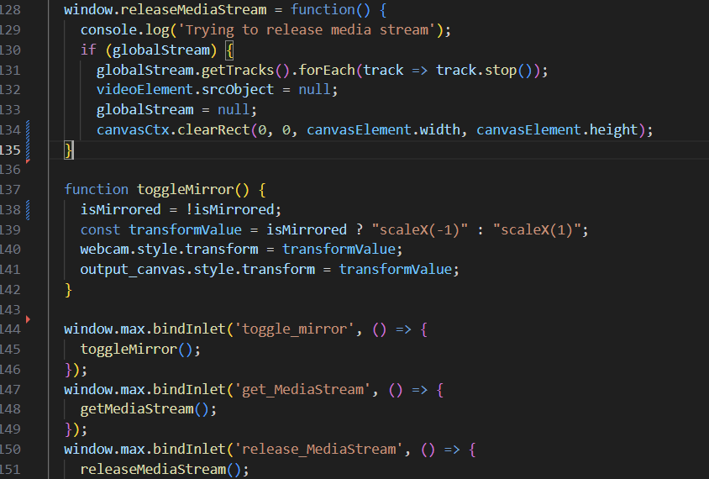

*Figure 4: JavaScript Code Content*

The getMediaStream function is a method for obtaining media streams, essentially capturing the video feed from the camera to display it on the screen. When releaseMediaStream is called, it means the captured video stream is released, making the camera feed unavailable for display in the video object within the web page simulated by jweb—resulting in a blank page. However, it's important to note that this method essentially captures the camera's video feed onto the web page or releases it from the web page but does not actually turn off the camera. Plans are in place to further develop a comprehensive camera toggle functionality to prevent the camera from being continuously active during program operation.

Furthermore, since the hand tracking model is based on real-time analysis of the captured video stream and displays the tracked hand model within the video, this mechanism falls into a state where the hand tracking model occupies an empty video stream once releaseMediaStream is called. Consequently, when getMediaStream is called again to establish a new video stream, the rendering results of the hand tracking cannot be displayed on the screen. A second invocation of getMediaStream is required to reconnect the hand tracking model with the new video stream, enabling the re-tracking of the hand. This operational mechanism will be further optimized in the future to ensure tracking can commence promptly after a video stream starts.

**Coordinate Processing & Sound Mapping**

Based on the hand tracking model provided by Mediapipe, significant joints on the hand are clearly marked, as shown in Figure 5, and their spatial coordinates can be obtained. Through the ‘window.max.outlet()’ function, data for both left and right hands are transmitted to Max, with dynamic recording of the xyz-axis coordinates of the index finger tip.

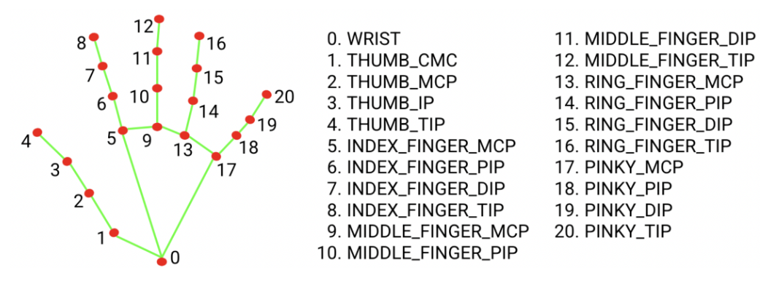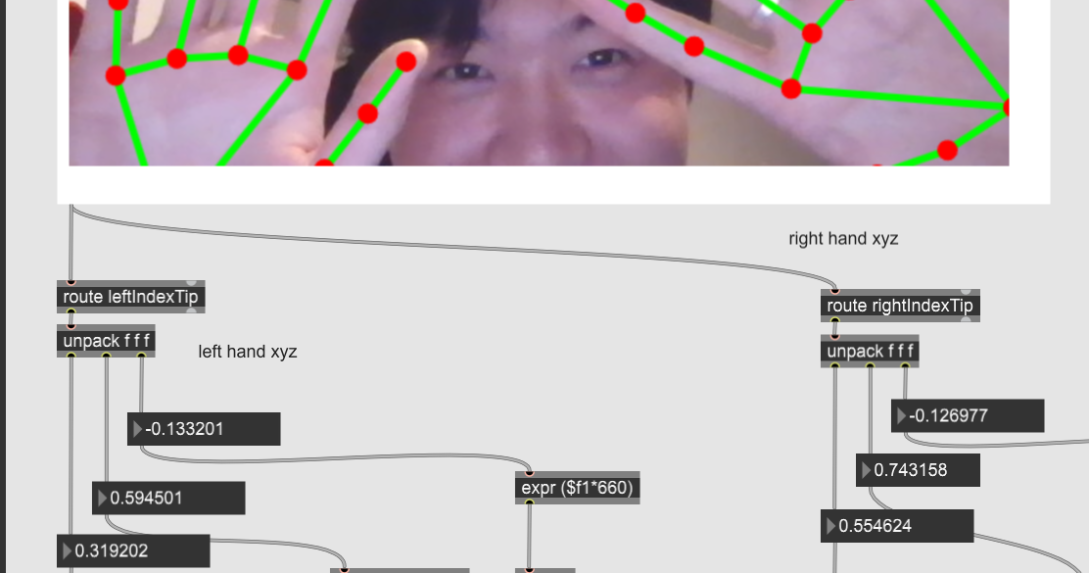

**xyz-axis coordinates**

*Figure 5: Hand Landmarks & Max detection*

Through testing, we discovered that the coordinate ranges for the x and y axes are 0-1, while the z-axis largely remains within the observable range of -0.013 to -0.5. Consequently, we decided to use the x and y axes to control the sounds of different piano keys, i.e., the high and low frequencies of do, re, mi, fa, sol, la, and si, while the z-axis, representing the distance of the hand from the screen, is defined as a parameter to control volume. The closer the hand is to the screen, the greater the volume effect.

After successfully mapping the index finger to virtual piano keys, moving our fingers in different areas of the air meant pressing different piano keys. Based on this, we speculated about mapping all ten fingertips of both hands to piano keys, anticipating the ability to simulate playing the piano by moving ten fingers in the air.

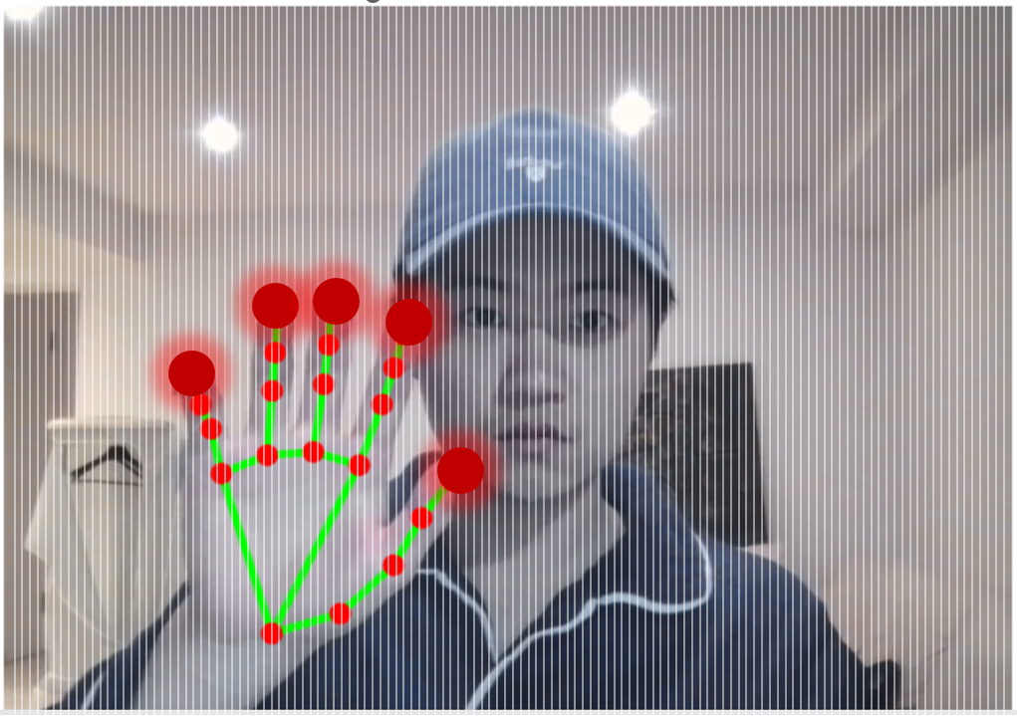 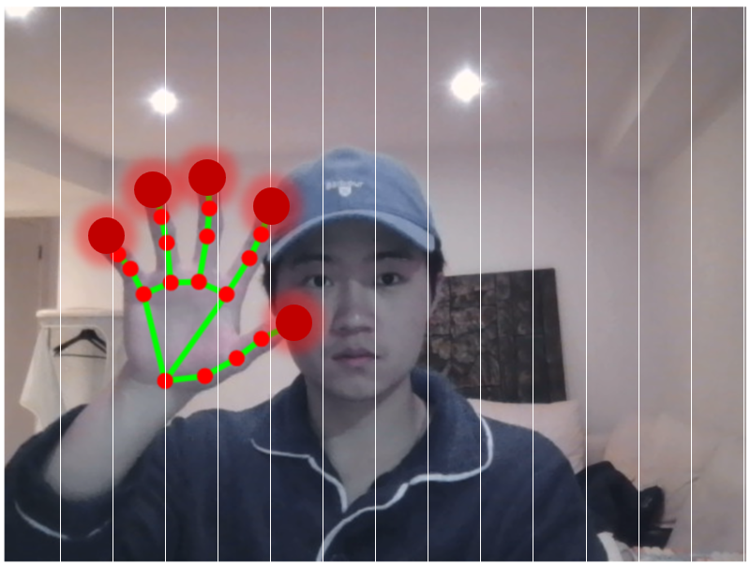

*Figure 6: Video Mapping x Axis Partition Display, Left (128 MIDI), Right (14 MIDI)*

However, the outcome was not as expected. The virtual piano is essentially provided by the kslider object in Max/MSP, which does not correspond to a real-world 88-key piano but rather to 128 MIDI notes. Mapping such a large number of notes onto the video captured by our camera, we found that a mere left-right or up-down shift of less than 0.01 in the coordinates could trigger the next MIDI note. Therefore, we initially attempted to map the notes across the horizontal x-axis to 14 notes and used the vertical y-axis for pitch modulation. This setup indeed avoided some unintended hand shifts causing incorrect key triggers, but still required users to keep their hands steady in the air, triggering music solely with finger movements. This could lead to arm fatigue over time, contradicting our project's initial intention of bringing joy to participants.

Moreover, when waving hands freely in the air, since all ten fingers could trigger MIDI notes, this would quickly produce a large amount of disordered reverb, making it difficult to discern a pattern and create beautiful melodies. Therefore, we ultimately decided to retain only the index finger's triggering effect, allowing for clear, monotone notes during small-scale waving and achieving various mixed sound effects during broad hand gestures.

**Conclusion & Future Improvements**

This installation design proved highly successful, flawlessly achieving our initial project goal of allowing participants to create music through hand movements, thus enabling both professional musicians and non-musicians to enjoy the fun of interactive music creation. When I randomly invited some friends and classmates from the Dyson School to experience the project, they highly praised it and thoroughly enjoyed this virtual space and sound interaction experience. One interviewee expressed it as having "a kind of magic to control sound."

Observing various indicators of the installation's success:

* Achieved timely tracking of participants' hand movements.
* Realized triggering effects on different musical notes through spatial position changes of participants' hands.
* Enabled participants to freely wave their hands, creating reverberation and variations in loudness and melody.
* Allowed participants to find patterns in the sounds generated by their movements and create their melodies based on the installation's triggering rules.

Therefore, overall, the project is considered quite successful. However, considering feedback from some participants and challenges faced by the team during the development process, this installation has significant potential for improvement.

* **Video Switch Functionality:** Enhance the video on/off feature to ensure smooth command execution, coupled with the ability to control the camera's activation and deactivation. This aims to provide a more seamless user experience by allowing for intuitive control over the camera, minimizing disruptions during interaction.
* **Visual Interaction for MIDI Division:** Introduce a visual interaction mechanism where triggering a MIDI note in a certain area of the screen results in a mild illumination and bounce effect in that region. This feature would visually represent the active interaction zone, making the musical creation process more engaging and intuitive for users.
* **Optimization of kslider and MIDI Mapping:** Refine the mapping equation between the kslider object and MIDI notes to ensure more accurate and timely feedback for the notes triggered by the user's hands. Enhanced precision in mapping would improve the musical expressiveness and responsiveness of the installation.
* **Instrumental Zoning of the Video Interface:** Further divide the video interface into sections, each defined as a different musical instrument (e.g., the left half triggers piano sounds, while the right half triggers guitar sounds). This zoning would enable the creation of a rich orchestral sound by allowing users to mix sounds from various instruments, potentially leading to symphonic creations.
* **Integration of Lighting Effects:** Incorporate lighting effects that respond to the melodies controlled by the user's hands, creating a more joyful and immersive symphonic music box experience. The dynamic interplay between sound and light would enhance the sensory experience, making the installation even more captivating and enjoyable.